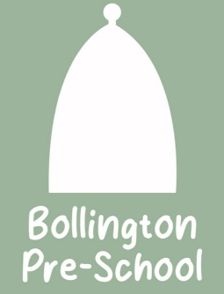
04. Health procedures
04.6 Oral health
Bollington Pre-School provides care for children and promotes health through promoting oral health and hygiene, encouraging healthy eating, healthy snacks and tooth brushing.
- Fresh drinking water is always available and easily accessible.
- Sugary drinks are not served.
- Only water and milk are served with morning and afternoon snacks.
- Children are offered healthy nutritious snacks with no added sugar.
- Parents/carers are discouraged from sending in confectionery as a snack or treat.
- Staff follow the Infant & Toddler Forum’s Ten Steps for Healthy Toddlers.
Where children clean their teeth when at the setting
- Children are encouraged to brush their teeth as part of the daily routine. Teeth should not be cleaned for at least one hour after a meal as this can cause loss of enamel.
- Each child has their own toothbrush, which is stored individually to prevent accidental contact and cross contamination.
- A small amount of toothpaste is put onto a blue paper towel before applying to the brush to prevent cross contamination.
- Toothbrushes are cleaned at each session and sterilised weekly in Milton or similar disinfecting fluid.
- Toothbrushes are changed every three months and provided by parents/carers.
- Oral hygiene activities are included in planning at least every three months when toothbrushes are changed.
- The setting co-ordinates with local oral health and ensure procedures are reviewed regularly, additional guidance from the local team may be added to this procedure.
Pacifiers/dummies
- Parents/carers are advised to stop using dummies/pacifiers once their child is 12 months old.
- Dummies that are damaged are disposed of and parents/carers are told that this has happened
Further guidance
Infant & Toddler Forum: Ten Steps for Healthy Toddlers www.infantandtoddlerforum.org/toddlers-to-preschool/healthy-eating/ten-steps-for-healthy-toddlers/

