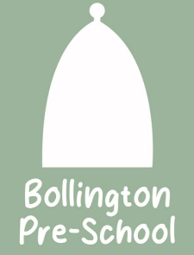
01 Health and safety procedures
01.9 Maintenance and repairs
Any faulty equipment or building fault at Bollington Pre-School is recorded, including:
- Date fault noted.
- Item or area faulty.
- Nature of the fault and priority.
- Is a risk assessment required?
- Who the fault reported to for action.
- Action taken and when.
- If no action taken by the agreed date, when and by whom the omission is followed up.
- Date action completed.
Any area that is unsafe because repair is needed, such as a broken window, should be made safe and separated off from general use.
- Any broken or unsafe item is taken out of use and labelled ‘out of use’.
- Any specialist equipment (e.g. corner seat for a disabled child) which is broken or unsafe should be returned to the manufacturer or relevant professional.
- Any item that is beyond repair is condemned. This action is recorded as the action taken and the item is removed from the setting’s inventory.
- Condemning items is done in agreement with the setting manager. Condemned items are then disposed of appropriately and not stored indefinitely on site.
- Where maintenance and repairs involve a change of access to the building whilst repairs are taking place, then a risk assessment is conducted to ensure the safety and security of the building is maintained.

