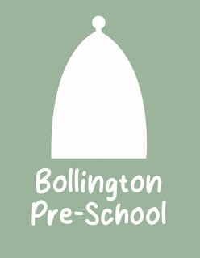
HOLIDAY DATES
2024-2025

Term | Pre-school Closes  at 5.00pm (*unless indicated otherwise) | Pre-school opens  at 8.00am on
Autumn Term starts |  | Tuesday 3rd September 2024
Autumn half term 2024 | Friday 25th October | Monday 4th November
Christmas 2024 | Thursday 19th December | Tuesday 7th January
Spring half term 2025 | Friday 14th February | Monday 24th February
Easter 2025 | Friday 4th April | Tuesday 23rd April
Spring Bank Holiday | Friday 1st May | Tuesday 5th May
Summer half term 2025 | Friday 23rd May | Monday 2nd June 2025
Summer 2025 | Friday 18th July
Inset Days | 1 day Mon 02/09/2024 | 1 day Fri 20/12/2024
1 day Mon 06/01/2025 | 1day Mon 22/04/2025 | 1 day Mon 21/07/2025

Please note that Inset days are tagged onto the beginning or end of holidays.

