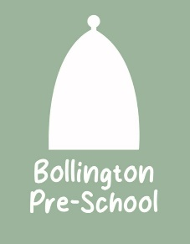
04. Health procedures
04.06 Oral health
The setting provides care for children and promotes health through promoting oral health and hygiene, encouraging healthy eating, healthy snacks and tooth brushing.
- Fresh drinking water is available at all times and easily accessible.
- Sugary drinks are not served.
- In partnership with parents, babies are introduced to an open free-flowing cup at 6 months and from 12 months are discouraged from using a bottle.
- Only water and milk are served with morning and afternoon snacks.
- Children are offered healthy nutritious snacks with no added sugar.
- Parents are discouraged from sending in confectionary as a snack or treat.
- Staff follow the Infant & Toddler Forum’s Ten Steps for Healthy Toddlers.
Pacifiers/dummies
- Parents are advised to stop using dummies/pacifiers once their child is 12 months old.
- Dummies that are damaged are disposed of and parents are told that this has happened
Further guidance
Infant & Toddler Forum: Ten Steps for Healthy Toddlers www.infantandtoddlerforum.org/toddlers-to-preschool/healthy-eating/ten-steps-for-healthy-toddlers/

