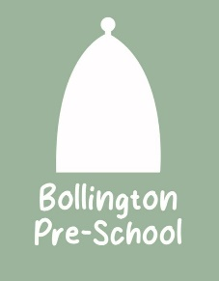
03 Food safety and nutrition procedures
03.6 Breast feeding
We recognise the important benefits of breastfeeding for both mothers and their babies. All mothers have the right to make informed choices and staff will ensure that clear and impartial information is available to all mothers. Staff will fully support parent’s choices.
We promote the Department of Health’s recommendations on feeding infants, as follows.
- Breastmilk is the best form of nutrition for infants.
- Exclusive breastfeeding is recommended for the first six months (26 weeks) of an infant’s life.
- Six months is the recommended age for the introduction of solid foods for infants.
- Breastfeeding (and/or breast milk substitutes, if used) should continue beyond the first six months, along with appropriate types and amounts of solid foods.
General
- Support is offered to promote and maximise the benefits of breastfeeding to new and expectant mothers attending the setting. Information is provided in the form of leaflets and ‘signposting’ to support groups and other sources of information.
- Publicity materials for bottle feeding and formula milk are not displayed within the setting.
- Mothers are enabled and supported to feed their babies within the setting. Every effort will be made for mothers who wish to feed their babies in private to do so.
- Toilet and baby changing areas are not offered as areas for breastfeeding as these cannot offer a hygienic environment.
- If a visitor to the setting objects to a mother breastfeeding, the ‘complainant’ will be moved to an area where s/he can no longer view the mother. The mother will not be disturbed.
- Staff co-operate with healthcare professionals and voluntary support groups to ensure a consistent approach to the promotion of breastfeeding benefits throughout the setting. This will be achieved by sharing of information and resources
- Staff do not discriminate against any mother in her chosen method of feeding and will not dictate choices to mothers
Further Information and resources
Breastfeeding and bottle-feeding advice (NHS) www.nhs.uk/conditions/baby/breastfeeding-and-bottle-feeding/

