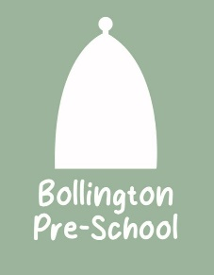
01 Health and safety procedures
01.18 Animals and pets
- Views of parents and children are considered when selecting a pet for the setting.
- Staff will be aware of any allergies or issues individual children may have with any animals/creatures.
- A risk assessment is conducted and considers any hygiene and safety risks posed by the animal or creature.
- Suitable housing for the animal is provided and is regularly cleaned and maintained.
- The correct food is offered at the right times and staff are knowledgeable of the pet’s welfare and dietary needs.
- Arrangements are made for weekend and holiday care for the animal/creature.
- There is appropriate pet health care insurance or other contingencies agreed and put in place to pay for veterinary care and the animal is registered with a local vet.
- All vaccinations and health measures such as de-worming are up to date.
- Children are taught correct handling of the pet and are always supervised.
- Children wash their hands after handling the pet and do not have contact with animal faeces, or soiled bedding.
- Members of staff wear single use vinyl/latex free gloves when cleaning/handling soiled bedding.
- Snakes and some other reptiles are not suitable pets for the setting due to infection risks.
- The manager will check with the owners/directors/trustees before introducing a new pet into the setting.
Animals bought in by visitors
- The owner of the animal/creature maintains responsibility for it in the setting.
- The owner carries out a risk assessment detailing how the animal/creature is to be handled and how any safety or hygiene issues will be addressed.
Further guidance
Good Practice in Early Years Infection Control (Alliance Publication)

