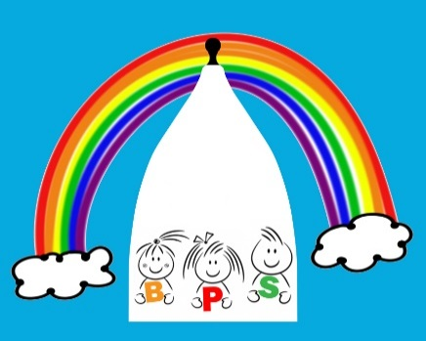
HOLIDAY DATES
2022-2023

Term | Pre-school Closes  at 5.00pm (*unless indicated otherwise) | Pre-school opens  at 8.00am on
Autumn Term starts |  | Monday 5th September 2022
Autumn half term 2022 | Friday 21st October | Monday 31st October
Christmas 2022 | Friday 16th December | Wednesday 4th January 2023
Spring half term 2023 | Friday 17th February | Monday 27th February
Easter 2023 | Friday 31st March 2023 | Tuesday 18th April
Spring Bank Holiday | Friday 28th April | Tuesday 2nd May
Summer half term 2023 | Friday 26th May | Monday 5th June 2023
Summer 2023 | Thursday 20th July
Inset Days | 1 day Thurs 01/09/2022 | 1 day Fri 02/09/2022
1 day Mon 17/04/2023 | 1day Tues 03/01/2023 | 1 day Fri 21/07/2023

Please note that Inset days are tagged onto the beginning or end of holidays.

