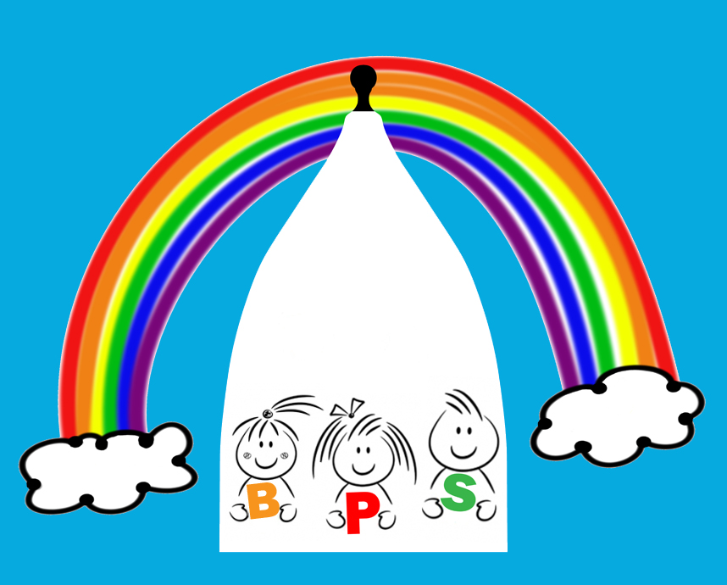
09 Childcare practice policy

Alongside associated procedures in 09.1-09.15 Childcare practice, this policy was adopted by Bollington Pre-School in December 2021.

Aim
Children are safe, happy, and eager to participate and to learn.
Objectives
- Babies and young children need to form a secure attachment to their key person when they join the setting to feel safe, happy and eager to participate and learn. It is their entitlement to be settled comfortably into a new environment.
- The needs of part-time children are considered.
- There is a procedure for when children do not settle and for prolonged absences.
- Introductions and induction of the parent is carried out before children start.
- Prime times of the day make the very best of routine opportunities to promote ‘tuning-in’ to the child emotionally and create opportunities for learning. We actively promote British values, inclusion, equality of opportunity and the valuing of diversity.
- We operate a positive behaviour management approach. Behaviour management procedures cover how staff should respond to all aspects of behaviour, including children who exhibit challenging behaviour towards other children. These procedures build on the Early Years Alliance’s approach to learning based on three key statements.
    - Learning is a lifelong process, which enables children and adults to contribute to and shape their world.
    - We want the curriculum we provide to help children to learn to:
- be confident and independent
- be aware of and responsive to their feelings
- make caring and thoughtful relationships with other people
- become increasingly excited by, interested in, and knowledgeable and questioning about the world around them.
    - We provide a wide range of interesting child-chosen and adult-initiated activities which:
- give children opportunities to use all their senses
- help children of different ages and stages to play together
- help children be the directors of their own learning
- help children develop an inquiring and questioning attitude to the world around them
The Early Years Foundation Stage is used as a framework to provide care and learning opportunities for babies and children under two years.
Older Children (2-5 years)
- To feel securely settled and ready to learn, children from two to five years need to form attachments with adults who care for them, primarily to a key person, but with other adults and children too. In this way children feel part of a community of learners; they can contribute to that community and receive from it. The three-stage model is applicable, but with some differences in the procedures for children moving up into the next group and for older children.
Waiting list and admissions
Our provision is accessible to children and families from all sections of the local and wider community. We aim to ensure that all sections of the community receive accessible information and that our admissions procedures are fair, clear, and open to all parents who apply for places. The availability of a place at the setting considers staff/child ratios, the age of the child and registration requirements.
- We endeavour to operate in an inclusive manner which enables all children and families to access our services.
- We also have regard for the needs of parents who are:
- looking to take up work, remain in work or extend their hours of work
- looking to commence training or education
- We work in partnership with the local authority and other agencies to ensure that our provision is accessible to all sections of the community.
- Services are widely advertised and information is accessible to all sections of the community.
- Where the number of children wanting places exceeds the number of places available a waiting list is operated using clear criteria for allocation of places as detailed in section 09.1 Waiting list and admissions procedure.
Funded places – free entitlement
All 3- and 4-year-olds in England are entitled to 15 hours free childcare each week for 38 weeks of the year. Some eligible 2 year olds are also entitled. Funded places are offered in accordance with national and local codes of practice and adherence to the relevant Provider Agreement/Contract with the local authority.

Legal References
Special Educational Needs and Disability Act 2001
Special Educational Needs and Disability Code of Practice (DfE and DHSC 2014)
Equality Act 2010
Childcare Act 2006

