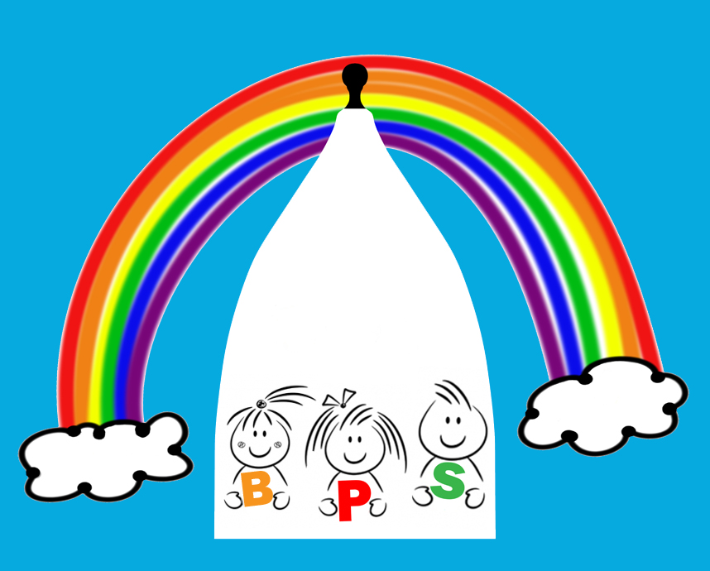

07 Record keeping policy

Alongside associated procedures in 07.1-07.4 Record keeping, this policy was adopted by Bollington Pre-School on 02/12/2021

Aim
We have record keeping systems in place for the safe and efficient management of the setting and to meet the needs of the children; that meet legal requirements for the storing and sharing of information within the framework of the GDPR and the Human Rights Act.

Objectives
- Children’s records are kept in personal files, divided into appropriate sections, and stored separately from their developmental records.
- Children’s personal files contain registration information as specified in procedure 07.1 Children’s records and data protection.
- Children’s personal files contain other material described as confidential as required, such as Early Help assessments, Early Support information or Education, Health and Care Plan (EHCP, case notes including recording of concerns, discussions with parents, and action taken, copies of correspondence and reports from other agencies.
- Ethnicity data is only recorded where parents have identified the ethnicity of their child themselves.
- Confidentiality is maintained by secure storage of files in a locked cabinet with access restricted to those who need to know. Client access to records is provided for within procedure 07.4 Client access to records.
- Staff know how and when to share information effectively if they believe a family may require a particular service to achieve positive outcomes
- Staff know how to share information if they believe a child is in need or at risk of suffering harm.
- Staff record when and to whom information has been shared, why information was shared and whether consent was given. Where consent has not been given and staff have taken the decision, in line with guidelines, to override the refusal for consent, the decision to do so is recorded.
- Guidance and training for staff specifically covers the sharing of information between professions, organisations, and agencies as well as within them, and arrangements for training takes account of the value of multi-agency as well as single agency working.

Records
The following information and documentation are also held:
- name, address and contact details of the provider and all staff employed on the premises
- name address and contact details of any other person who will regularly be in unsupervised contact with children
- a daily record of all children looked after on the premises, their hours of attendance and their named key person
- certificate of registration displayed and shown to parents on request
- records of risk assessments
- record of complaints
Legal references
General Data Protection Regulation 2018
Freedom of Information Act 2000
Human Rights Act 1998
Statutory Framework for the Early Years Foundation Stage (DfE 2021)
Data Protection Act 2018

Further guidance
Information Sharing: Advice for practitioners providing safeguarding services to children, young people, parents and carers. (HMG 2018)

