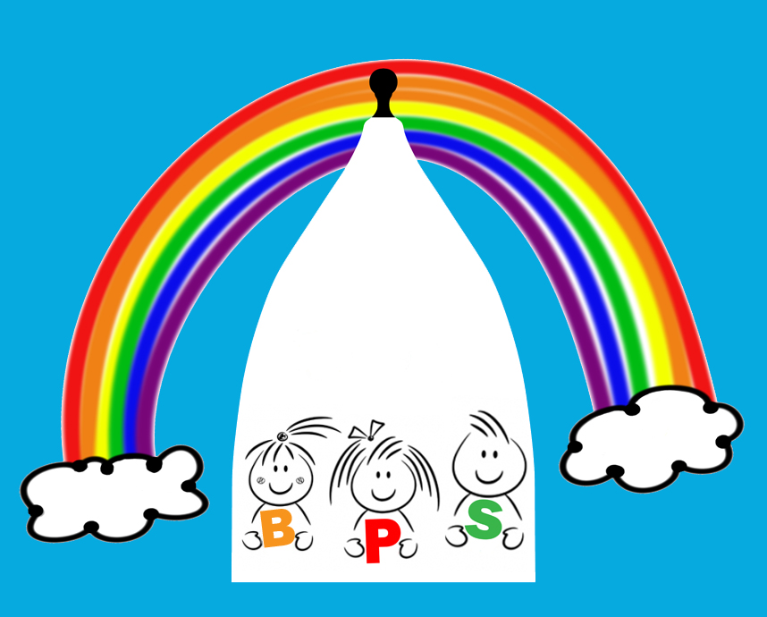

10.1 Early years prospectus

Bollington Preschool’s Early Years Prospectus for Parents
Water Street, Bollington, SK10 5PB
01625 400128
info@bollingtonpreschool.org.uk

Welcome to Bollington Preschool and thank you for registering your child with us

We know how important your child is and aim to deliver the highest quality of care and education to help them to achieve their best.

his prospectus aims to provide you with an introduction to Bollington Preschool, our routines, our approach to supporting your child’s learning and development and how we aim to work together with you to best meet your child’s individual needs. This should be read alongside our Childcare Terms and Conditions for a full description of our services.

Our setting aims to:

- provide high quality care and education for children below statutory school age;
- work in partnership with parents to help children to learn and develop;
- add to the life and well-being of the local community; and
- offer children and their parents a service that promotes equality and values diversity.

Parents

You are regarded as members of our setting who have full participatory rights. These include a right to be:
- valued and respected;
- kept informed;
- consulted;
- involved; and
- included at all levels.

As a voluntary managed setting, we also depend on the good will of parents and their involvement to keep going. Membership of the setting carries expectations on you for your support and commitment.

Children's development and learning

We aim to ensure that each child:
- is in a safe and stimulating environment;
- is given generous care and attention, because of our ratio of qualified staff to children, as well as volunteer helpers;
- has the chance to join in with other children and adults to live, play, work and learn together;
- is helped to take forward her/his learning and development by being helped to build on what she/he already knows and can do;
- has a personal key person who makes sure each child makes satisfying progress;
- is in a setting that sees parents as partners in helping each child to learn and develop; and
- is in a setting in which parents help to shape the service it offers.

The Early Years Foundation Stage
Provision for the development and learning of children from birth to 5 years is guided by the Early Years Foundation Stage. Our provision reflects the four overarching principles of the Statutory Framework for the Early Years Foundation Stage (DfE 2014):

- A Unique Child
Every child is a unique child who is constantly learning and can be resilient, capable, confident and self-assured.

- Positive Relationships
Children learn to be strong and independent through positive relationships.

- Enabling Environments
Children learn and develop well in enabling environments, in which their experiences respond to their individual needs and there is a strong partnership between practitioners, parents and carers.

- Learning and Development
Children develop and learn in different ways and at different rates. The framework covers the education and care of all children in early years provision including children with special educational needs and disabilities.

How we provide for development and learning

Children start to learn about the world around them from the moment they are born. The care and education offered by our setting helps children to continue to do this by providing all of the children with interesting activities that are appropriate for their age and stage of development.

The Areas of Development and Learning comprise:
- Prime Areas
- Personal, social and emotional development.
- Physical development.
- Communication and language.

- Specific Areas
- Literacy.
- Mathematics.
- Understanding the world.
- Expressive arts and design.

For each area, the level of progress that children are expected to have attained by the end of the Early Years Foundation Stage is defined by the Early Learning Goals. These goals state what it is expected that children will know, and be able to do, by the end of the reception year of their education.

The Early Years Outcomes (DfE 2013) guidance sets out the likely stages of progress a child makes along their progress towards the Early Learning Goals. Our setting has regard to these when we assess children and plan for their learning. Our programme supports children to develop the knowledge, skills and understanding they need for:

Personal, social and emotional development
- making relationships;
- self-confidence and self-awareness; and
- managing feelings and behaviour.

Physical development
- moving and handling; and
- health and self-care.

Communication and language
- listening and attention;
- understanding; and
- speaking.

Literacy
- reading; and
- writing.
Mathematics
- numbers; and
- shape, space and measure.

Understanding the world
- people and communities;
- the world; and
- technology.

Expressive arts and design
- exploring and using media and materials; and
- being imaginative.

Our approach to learning and development and assessment

Learning through play
Being active and playing supports young children’s learning and development through doing and talking. This is how children learn to think about and understand the world around them. We use the EYFS statutory guidance on education programmes to plan and provide opportunities which will help children to make progress in all areas of learning. This programme is made up of a mixture of activities that children plan and organise for themselves and activities planned and led by practitioners.

Characteristics of effective learning
We understand that all children engage with other people and their environment through the characteristics of effective learning that are described in the Early Years Foundation Stage as:
- playing and exploring - engagement;
- active learning - motivation; and
- creating and thinking critically - thinking.

We aim to provide for the characteristics of effective learning by observing how a child is learning and being clear about what we can do and provide in order to support each child to remain an effective and motivated learner.

Assessment
We assess how young children are learning and developing by observing them frequently. We use information that we gain from observations, as well as from photographs or videos of the children, to document their progress and where this may be leading them. We believe that parents know their children best and we will ask you to contribute to assessment by sharing information about what your child likes to do at home and how you, as parents, are supporting development.

We make periodic assessment summaries of children’s achievement based on our on-going development records. These form part of children’s records of achievement. We undertake these assessment summaries at regular intervals, as well as times of transition, such as when a child moves into a different group or when they go on to school.

The progress check at age two
The Early Years Foundation Stage requires that [we/I] supply parents and carers with a short written summary of their child’s development in the three prime areas of learning and development - personal, social and emotional development; physical development; and communication and language - when a child is aged between 24 - 36 months. Your child’s key person is responsible for completing the check using information from on-going observational assessments carried out as part of our everyday practice, taking account of the views and contributions of parents and other professionals.

Records of achievement

We keep a record of achievement for each child. Your child's record of achievement helps us to celebrate together her/his achievements and to work together to provide what your child needs for her/his well-being and to make progress.

Your child's key person will work in partnership with you to keep this record. To do this you and she/he will collect information about your child's needs, activities, interests and achievements. This information will enable the key person to identify your child's stage of progress. Together, we will then decide on how to help your child to move on to the next stage.

Working together for your children

We maintain the ratio of adults to children in the setting that is set by the Safeguarding and Welfare Requirements. We also have volunteer parent helpers, where possible, to complement these ratios. This helps us to:
- give time and attention to each child;
- talk with the children about their interests and activities;
- help children to experience and benefit from the activities we provide; and
- allow the children to explore and be adventurous in safety.

The staff who work at our setting are:
Name | Job Title | Qualifications and Experience
Elizabeth Ryan | Early Years Manager | CACHE Level 3 Early Years Educator  Paediatric First Aid Trained  Health & Safety Level 2
Natalie Corbett | Early Years Business Manager | Paediatric First Aid Trained
Sandra Foster | Deputy Manager  SENCO | City and Guilds NVQ Level 3  Early Years Care and Education  Paediatric First Aid Trained
Liz Hunt | Early Years Assistant  Health and Safety Co-ordinator | Level 2 Food Hygiene  Level 2 Health &Safety  Paediatric First Aid Trained
Karen Hasler | Early Years Practitioner  Quality of Teaching and Learning Lead | Early Years QTS  PGCE in Primary BA Linguistics and Philosophy  Paediatric First Aid Trained
Becky Moores | Early Years Practitioner | Foundation Degree in Early Years  Level 5  CACHE NVQ Level 3  Nursery Training
Danae Parsons | Early Years Practitioner | NVQ Level 2  Paediatric First Aid Trained
Nicola Fall | Early Years Practitioner | CACHE NVQ Level 3  Special support in teaching and learning
Louise Nolan | Early Years Practitioner | CACHE NVQ Level 3 Diploma in Children’s and young people’s workforce  Paediatric First Aid Trained
Alison Sampson | Early Years Practitioner | CACHE NVQ Level 3  Diploma in Childcare and Education  Paediatric First Aid Trained
Jodie Manning | Early Years Practitioner | CACHE NVQ Level 3  Diploma in Childcare and Education  Paediatric First Aid Trained
Vicki Cook | Early Years Practitioner | NVQ Level 3 in Playwork  NVQ Level 2  Children and Young People’s workforce
Emma Shore | Early Years Practitioner | (Currently on Maternity leave)
Gill Reynolds | Early Years Assistant

We are open for |  |  | 38 |  | weeks each year.
We are open for |  |  | 5 |  | days each week
The times we are open are |  |  | 8am-5pm
We provide care and education for young children between the ages of:
2 | and | 5 |  | years.

How parents take part in the setting

Our setting recognises parents as the first and most important educators of their children. All of our staff see themselves as partners with parents in providing care and education for their children. There are many ways in which parents take part in making our setting a welcoming and stimulating place for children and parents, such as:
- exchanging knowledge about their children's needs, activities, interests and progress with our staff;
- contributing to the progress check at age two;
- helping at sessions of the setting;
- sharing their own special interests with the children;
- helping to provide and look after the equipment and materials used in the children's play activities;
- being part of the management of the setting where appropriate;
- taking part in events and informal discussions about the activities and curriculum provided by the setting;
- joining in community activities, in which the setting takes part; and
- building friendships with other parents in the setting.

The parents' rota

Our setting has a dated rota which parents can sign if they would like to help at a particular session or sessions of the setting. Helping at the session enables parents to see what the day-to-day life of our setting is like and to join in helping the children to get the best out of their activities.

Joining in

Joining the rota is not the only means of taking part in the life of the setting. Parents can offer to take part in a session by sharing their own interests and skills with the children. Parents have visited the setting to play the clarinet for the children, show pictures of the local carnival held in their neighbourhood, and show the children their collection of shells.

We welcome parents to drop into the setting to see it at work or to speak with the staff.

Key person and your child

Our setting uses a key person approach. This means that each member of staff has a group of children for whom she/he is particularly responsible. Your child's key person will be the person who works with you to make sure that the childcare that we provide is right for your child's particular needs and interests. When your child first starts at the setting, she/he will help your child to settle and throughout your child's time at the setting, she/he will help your child to benefit from our activities.

Learning opportunities for adults

As well as gaining childcare qualifications, our staff take part in further training to help them to keep up-to date with thinking about early years care and education. We also keep up-to-date with best practice, as a member of the Pre-school Learning Alliance, through Under 5 magazine and other publications produced by the Alliance. The current copy of Under 5 is available for you to read. From time to time we hold learning events for parents. These usually look at how adults can help children to learn and develop in their early years.

The setting's timetable and routines

Our setting believes that care and education are equally important in the experience which we offer children. The routines and activities that make up the day in our setting are provided in ways that:
- help each child to feel that she/he is a valued member of the setting;
- ensure the safety of each child;
- help children to gain from the social experience of being part of a group; and
- provide children with opportunities to learn and help them to value learning.

The day

We organise the day so that children can take part in a variety of child-chosen and adult-led activities. These take account of children's changing energy levels throughout the day. We cater for children's individual needs for rest and quiet activities during the day. Outdoor activities contribute to children's health, their physical development and their knowledge of the world around them.

Snacks and meals

We make snacks and meals a social time at which children and adults eat together. We plan the menus for snacks and meals so that they provide the children with healthy and nutritious food. Please tell us about your child's dietary needs and we will plan accordingly.

Clothing

We provide protective clothing for the children when they play with messy activities. We encourage children to gain the skills that help them to be independent and look after themselves. These include taking themselves to the toilet and taking off, and putting on, outdoor clothes. Clothing that is easy for them to manage will help them to do this.

Policies

Our staff can explain our policies and procedures to you. Copies of which are available on our website or in the policies and procedures file located in the office.

Our policies help us to make sure that the service provided by our setting is a high quality one and that being a member of the setting is an enjoyable and beneficial experience for each child and her/his parents.

Policies are reviewed annually or as stated in the policy or to reflect any changes in legislation. This helps us to make sure that the policies are enabling our setting to provide a quality service for its members and the local community.
Information we hold about you and your child
We have procedures in place for the recording and sharing of information/ data about you and your child that is compliant with the principles of the General Data Protection Regulations (2018) as follows:
The data is we collect is
- Processed fairly, lawfully and in a transparent manner in relation to the data subject [you and your family]
- Collected for specified, explicit and legitimate purposes and not further processed for other purposes incompatible with those purposes.
- Adequate, relevant and limited to what is necessary in relation to the purposes for which data is processed.
- Accurate and, where necessary, kept up to date.
- Kept in a form that permits identification of data subjects [you and your family] for no longer than is necessary for the purposes for which the personal data is processed.
- Processed in a way that ensures appropriate security of the personal data including protection against unauthorised or unlawful processing and against accidental loss, destruction or damage, using appropriate technical or organisational measures.

When you register your child with us, we will provide you with a privacy notice that gives you further details of how we fulfil our obligations with regard to your data.

Safeguarding children

Our setting has a duty under the law to help safeguard children against suspected or actual ‘significant harm’. Our employment practices ensure children against the likelihood of abuse in our setting and we have a procedure for managing complaints or allegations against a member of staff.

Our way of working with children and their parents ensures that we are aware of any problems that may emerge and can offer support, including referral to appropriate agencies when necessary, to help families in difficulty.

Special needs

To make sure that our provision meets the needs of each individual child, we take account of any special needs a child may have. We work to the requirements of the Special Educational Needs and Disability Code of Practice: 0 to 25 years (2015).

Our Special Educational Needs Co-ordinator is | Sandra Foster

The management of our setting

Our setting is a charity and as such is managed by a volunteer management committee - whose members are elected by the parents of the children who attend our setting. The elections take place at our Annual General Meeting. The committee make up the registered person with Ofsted and are responsible for:
- managing our finances;
- employing and managing our staff;
- making sure that we have, and work to, policies that help us to provide a high quality service; and
- making sure that we work in partnership with parents.

The Annual General Meeting is open to the parents of all of the children who attend our setting. It is our shared forum for looking back over the previous year's activities and shaping the coming year's plan.

Fees

Fees are applied to those hours which fall outside of the government funded hours.
The fees are £4.50 per hour 3year + and £5.35 per hour 2years payable each month. Fees must still be paid if children are absent without notice for a short period of time. If your child has to be absent over a long period of time talk to Elizabeth Ryan who is our manager or Sandra Foster our Deputy Manager.
For your child to keep her/his place at our setting, you must pay the fees.

For children aged 3years + a 50p per session snack charge is applied. This is optional and parents can send in children's snack if they prefer.

Starting at our setting

The first days
We want your child to feel happy and safe with us. To make sure that this is the case, our staff will work with you to decide on how to help your child to settle into the setting. Our policy on the Role of the Key Person and Settling-in is enclosed with this prospectus or is available from Natalie Corbett our Business Manager.

We hope that you and your child enjoy being members of our setting and that you both find taking part in our activities interesting and stimulating. Our staff are always ready and willing to talk with you about your ideas, views or questions.

