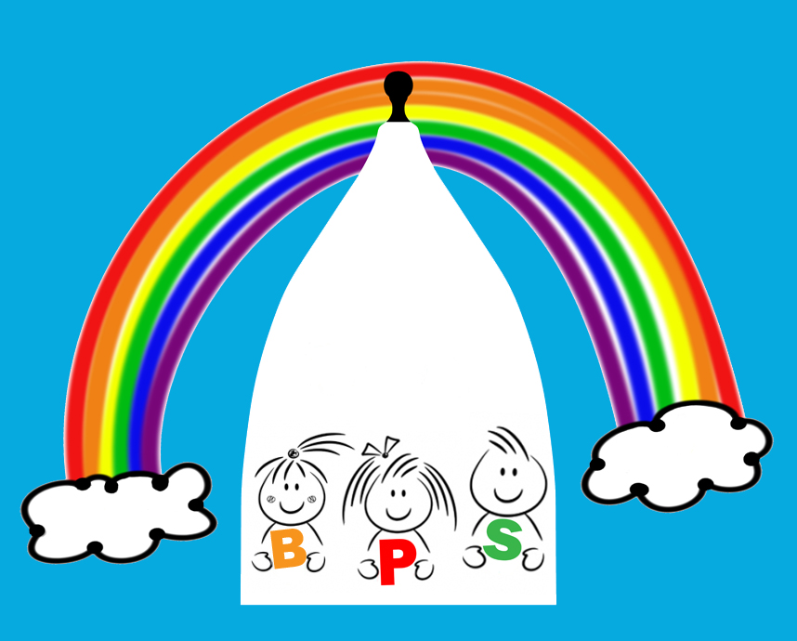
10.3 Application to join
Bollington Preschool Application Form
Water Street, Bollington, Cheshire, SK10 5PB
Tel 01625 400128 Email info@bollingtonpreschool.org.uk

Charity Number 1022029
Ofsted Registration Number EY452060

Personal details
First name(s) of child:
Surname of child: |  |  |  |  |  |  |  |  | Date of birth:
Full address:
 |  |  |  |  |  |  |  |  | Postcode:
Parent/carer name (1):
Relationship to child:
Full address (if different):
 |  |  |  |  |  |  |  |  | Postcode:
Daytime/work tel: |  |  |  |  |  |  | Home: |  |  | Mobile:
Parent/carer name (2):
Relationship to child:
Full address (if different):
 |  |  |  |  |  |  |  |  | Postcode:
Daytime/work tel: |  |  |  |  |  |  | Home: |  |  | Mobile:

Session request
Preferred start date:
Please tick the sessions you would like your child to attend:
Breakfast 8am-9am |  |  |  |  |  | □ Monday |  |  | □ Tuesday |  |  |  | □ Wednesday |  |  |  | □ Thursday |  |  | □ Friday
Morning 9 am-12noon |  |  |  |  |  | □ Monday |  |  | □ Tuesday |  |  |  | □ Wednesday |  |  |  | □ Thursday |  |  | □ Friday
Afternoon 12noon-3pm |  |  |  |  |  | □ Monday |  |  | □ Tuesday |  |  |  | □ Wednesday |  |  |  | □ Thursday |  |  | □ Friday
Late afternoon 3pm-5pm |  |  |  |  |  | □ Monday |  |  | □ Tuesday |  |  |  | □ Wednesday |  |  |  | □ Thursday |  |  | □ Friday
On receipt of this form we will then contact you to confirm your booking.

Once your child is offered a place and you accept it, on admission further personal information and family details are required for our records. Your child’s birth certificate is required at this point with a copy made for our file.
If you find that you no longer need the place, please inform us as soon as possible. Should you decide you no longer need the place we will not retain the details on this application form (see our Privacy Notice).
Signed parent/carer (1): |  |  |  |  |  |  |  |  |  |  |  |  |  |  |  | Date:
Signed parent/carer (2): |  |  |  |  |  |  |  |  |  |  |  |  |  |  |  | Date:
Please be advised that this application form and offer of a place is subject to our terms and conditions which are contained within the parent handbook. By signing this document, you acknowledge that you have read, understood and agree to these terms and conditions.
For office use only:
Deposit paid: |  |  | N/A |  |  |  |  |  |  |  |  | Date paid:
Tear off the following part to return to the parent(s)
A place will be available for |  |  |  |  |  |  |  |  |  |  |  |  |  |  |  |  |  |  | (child’s name)
* on |  |  |  |  |  |  |  | (date) |  | * or; we will notify you when a place becomes free.
Signed on behalf of the provider:
Name: |  |  |  |  |  |  |  |  |  |  | Job title:

*Please delete whichever is not applicable.

