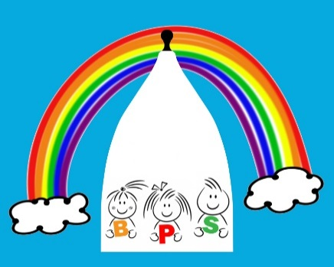
HOLIDAY DATES
2018-2019

Term | Pre-school Closes  at 5.00pm (*unless indicated otherwise) | Pre-school opens  at 8.00am on
Autumn half term 2018 | Friday 26th October | Monday 5th November
Christmas 2018 | Thursday 20th December (*12 noon) | Thursday 3rd January 2019
Spring half term 2019 | Friday 15th February | Tuesday 26th February
Easter 2019 | Friday 5th April | Wednesday 24th April
Spring Bank Holiday | Friday 3rd May | Tuesday 7th May
Summer half term 2019 | Friday 24th May | Monday 3rd June
Summer 2019 | Friday 19th July (*12 noon)
Inset Days | 1 day Mon 03/09/2018
½ day 20/12/2018 | 1 day Mon 25/02/2019 | 1day Tues 23/04/2019
½ day Fri 19/07/2019 | 1 day Mon 22/07/2019

Please note that Inset days are tagged onto the beginning or end of holidays.

