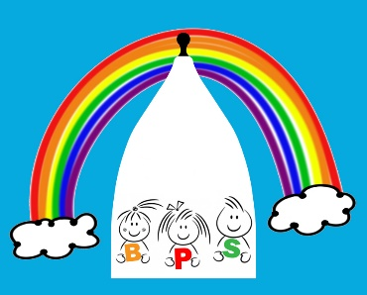

BOLLINGTON PRE SCHOOL CHARGES

Session | 2-3 years | 3-5 years
B/fast 8am-9am | £4.85 | £4.00
Morning 9am-12noon | £14.55 | £12.00
Afternoon 12noon – 3pm | £14.55 | £12.00
After Pre School 3pm -5pm | £9.70 | £8.00
Full Day 8-5pm | £43.65 | £36.00

We provide places for Government Funded 2 & 3 year olds please ask for further details.

