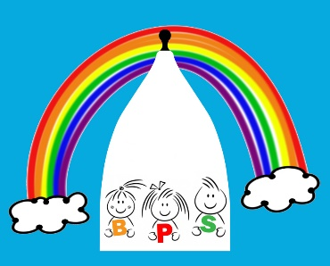

1.1 Children’s rights and entitlements

Policy statement

- We promote children's right to be strong, resilient and listened to by creating an environment in our setting that encourages children to develop a positive self-image, which includes their heritage arising from their colour and ethnicity, their languages spoken at home, their religious beliefs, cultural traditions and home background.
- We promote children's right to be strong, resilient and listened to by encouraging children to develop a sense of autonomy and independence.
- We promote children's right to be strong, resilient and listened to by enabling children to have the self-confidence and the vocabulary to resist inappropriate approaches.
- We help children to establish and sustain satisfying relationships within their families, with peers, and with other adults.
- We work with parents to build their understanding of, and commitment to, the principles of safeguarding all children.

What it means to promote children’s rights and entitlements to be ‘strong, resilient and listened to’.

To be strong means to be:
- secure in their foremost attachment relationships, where they are loved and cared for by at least one person who is able to offer consistent, positive and unconditional regard and who can be relied on;
- safe and valued as individuals in their families and in relationships beyond the family, such as day care or school;
- self-assured and form a positive sense of themselves – including all aspects of their identity and heritage;
- included equally and belong in [our/my] setting and in community life;
- confident in their own abilities and proud of their achievements;
- progressing optimally in all aspects of their development and learning;
- part of a peer group in which they learn to negotiate, develop social skills and an identity as global citizens, respecting the rights of others in a diverse world; and
- able to represent themselves and participate in aspects of service delivery that affects them, as well as aspects of key decisions that affect their lives.

To be resilient means to:
- be sure of their self-worth and dignity;
- be able to be assertive and state their needs effectively;
- be able to overcome difficulties and problems;
- be positive in their outlook on life;
- be able to cope with challenge and change;
- have a sense of justice towards themselves and others;
- develop a sense of responsibility towards themselves and others; and
- be able to represent themselves and others in key decision making processes.

To be listened to means:
- adults who are close to children recognise their need and right to express and communicate their thoughts, feelings and ideas;
- adults who are close to children are able to tune in to their verbal, sign and body language in order to understand and interpret what is being expressed and communicated;
- adults who are close to children are able to respond appropriately and, when required, act upon their understanding of what children express and communicate; and
- adults respect children’s rights and facilitate children’s participation and representation in imaginative and child centred ways in all aspects of core services.

This policy was adopted by | Bollington Preschool
On | 5th September 2017
Date to be reviewed | ^{4th} September 2018
Signed on behalf of the provider | Shirley Sugden Rachel Forster
Name of signatory
Role of signatory | Staff Manager Chairperson

